1. List the owner number, last name, and first name of every property owner.

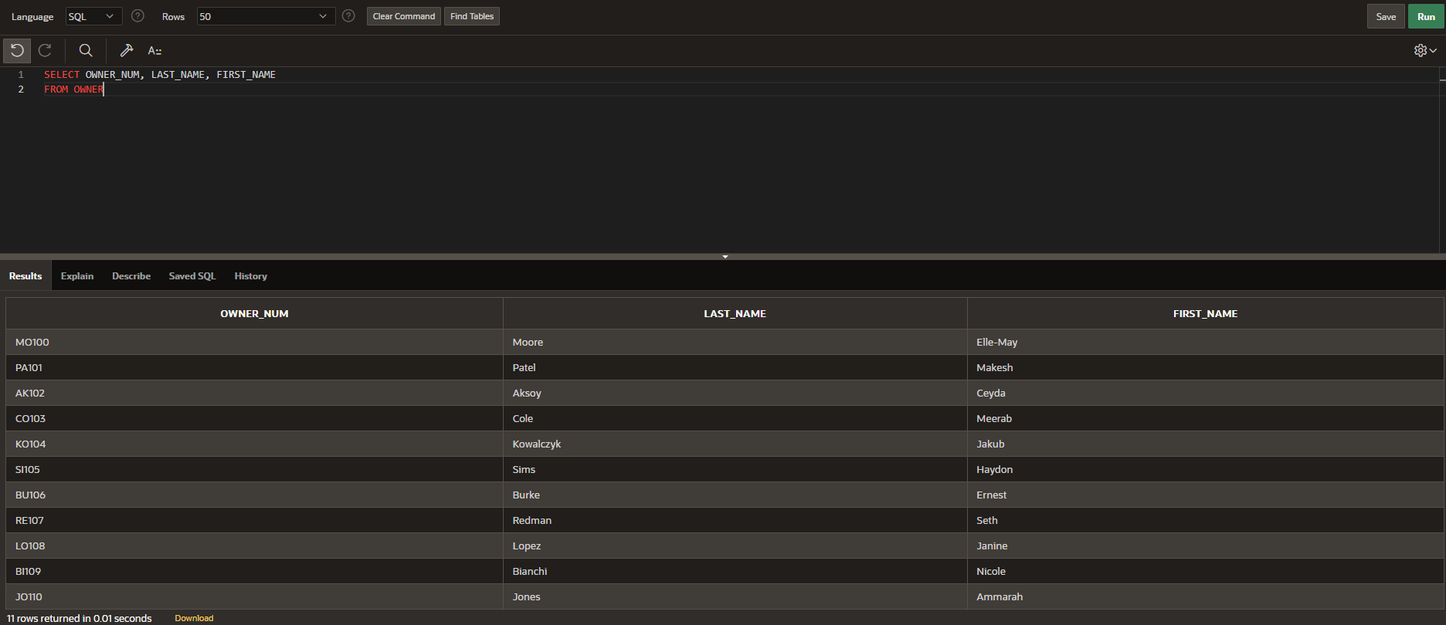

1. List the complete PROPERTY table (all rows and all columns)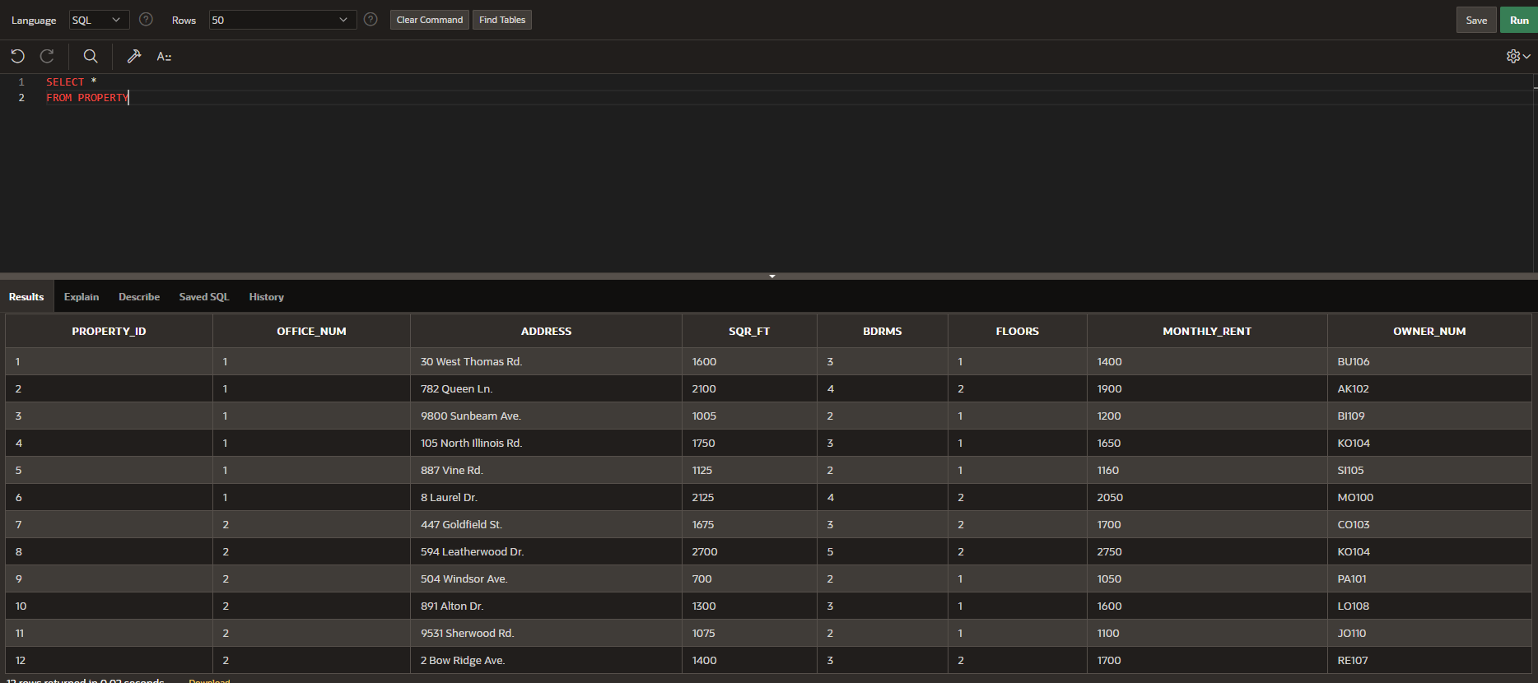
2. List the last name and first name of every owner who lives in Seattle.

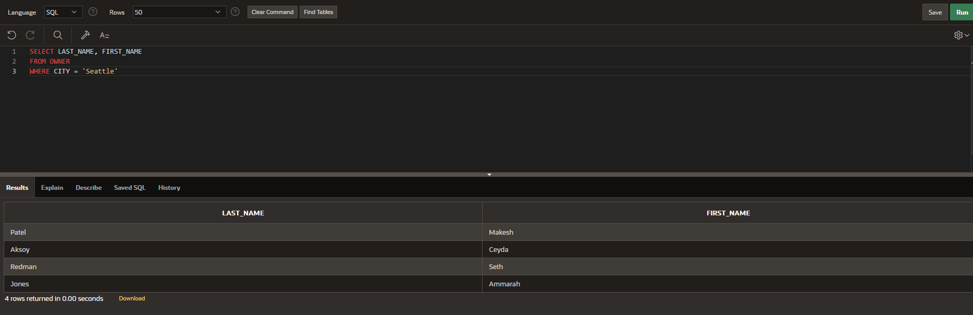

1. List the last name and first name of every owner who does not live in Seattle.

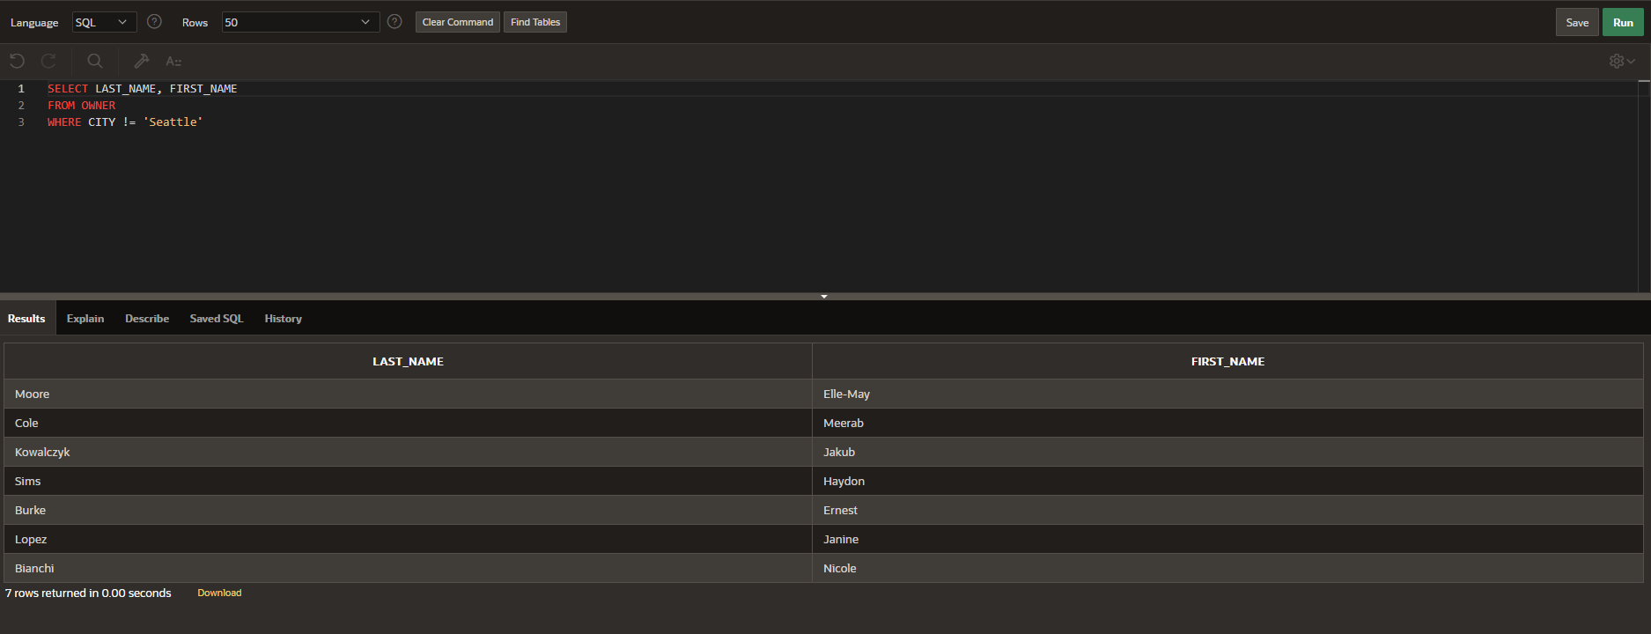

1. List the property ID and office number for every property whose square footage is equal to or less than 1,400 square feet.

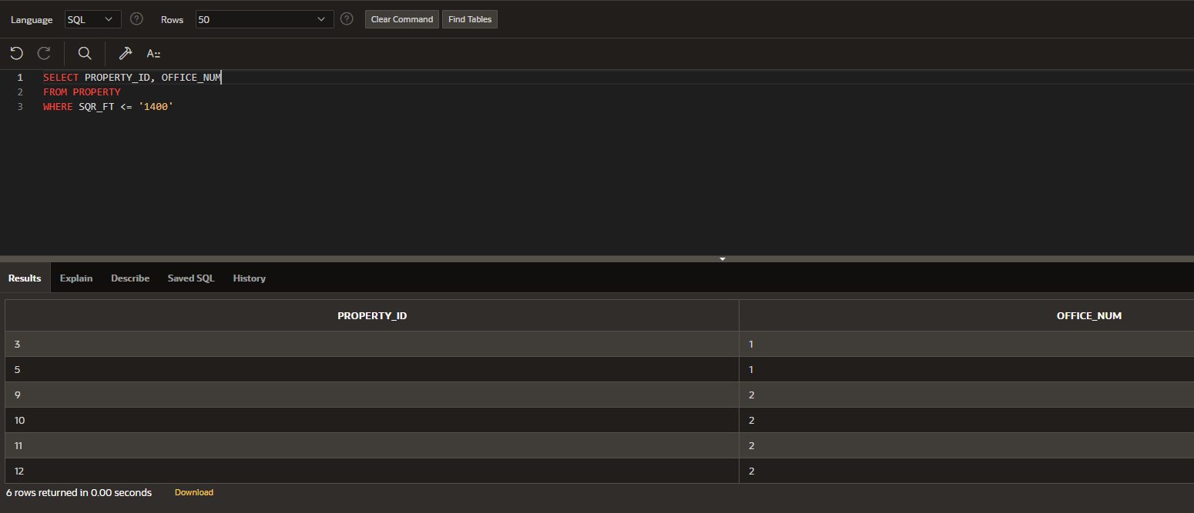

1. List the office number and address for every property with three bedrooms.

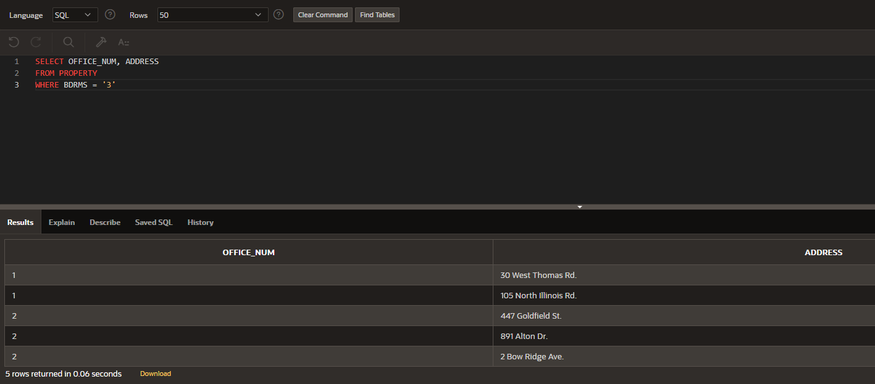

1. List the property ID for every property with two bedrooms that is managed by StayWell-Georgetown.

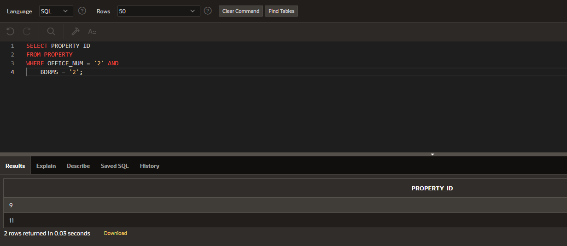

1. List the property ID for every property with a monthly rent that is between $1,350 and $1,750.

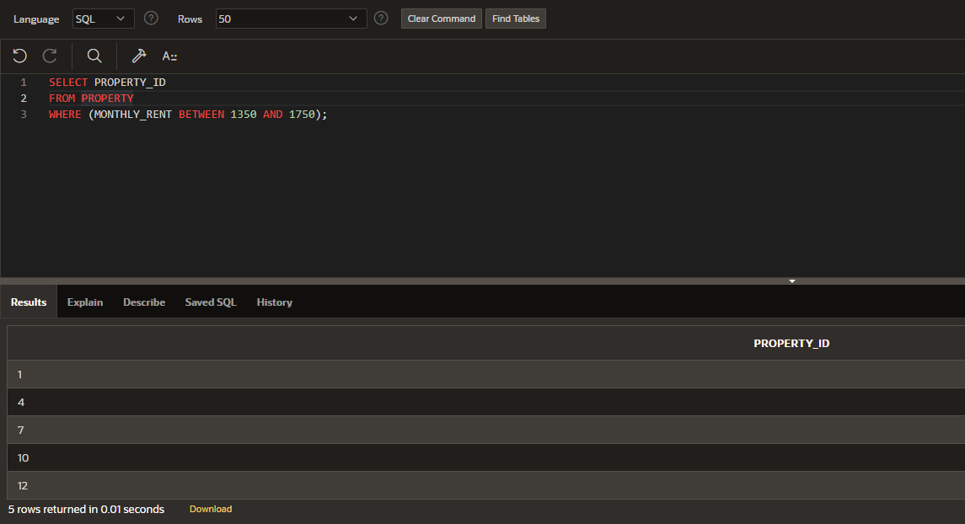

1. List the property ID for every property managed by StayWell-Columbia City whose monthly rent is less than $1,500.

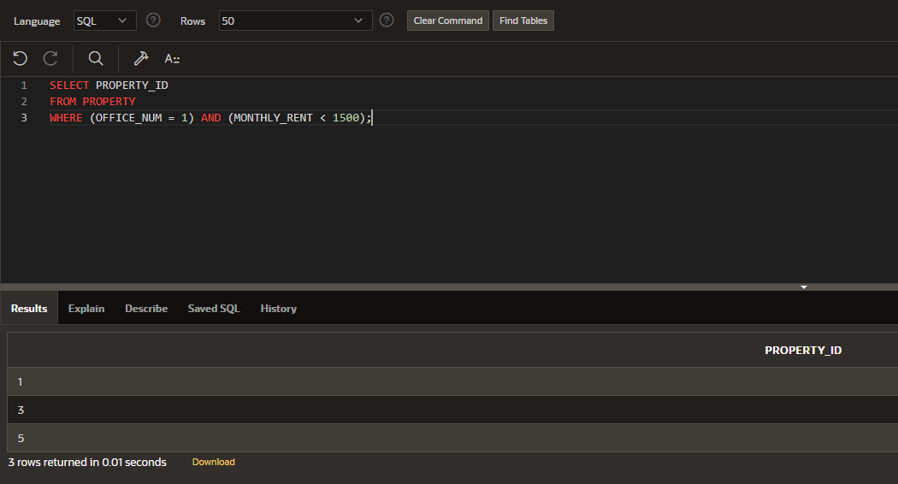

1. Labor is billed at the rate of $35 per hour. List the property ID, category number, estimated hours, and estimated labor cost for every service request. To obtain the estimated labor cost, multiply the estimated hours by 35. Use the column name ESTIMATED_COST for the estimated labor cost.

